PART VI — THE SELF-LEARNING LAYER
Chapter 28
What “Self-Learning” Actually Means
“A system can improve from experience without pretending that its model retrained itself.”

Chapter 28 — What “Self-Learning” Actually Means
“Self-learning” is one of the easiest labels to overstate. An agent may search repeatedly, judge its own draft, remember a user correction, or retrieve an earlier successful answer. These behaviors can improve future results, but they do not all change the model in the same way. Precise language matters because memory, training, and reinforcement have different costs, risks, and evidence requirements.
Memora calls itself a self-learning agentic RAG system, but its core mechanism is deliberately modest and auditable. Successful interactions can be distilled into a `learned_qa` collection; later retrievals search that collection independently from source documents. Failure memory records bad variants and user thumbdowns so repeated queries can avoid prior trajectories. The base LLM’s parameters remain unchanged. By the end of this chapter, you will be able to distinguish agency from learning, explain three legitimate improvement paths, and design a memory-injection loop without turning one hallucination into permanent “knowledge.”

28.1 The honest truth: agentic does not mean self-learning
An agentic system chooses actions at runtime. A self-improving system changes something that affects later runs. Those are independent axes. An agent can be highly adaptive during one request yet begin the next request exactly as it began the first. Conversely, a non-agentic recommendation service can update a ranking model from user feedback without performing any multi-step reasoning.
Definition — Self-improvement
A measurable change derived from prior experience that alters the behavior or information available to future runs. The changed artifact may be memory, prompts, retrieval policy, configuration, or model weights; the mechanism must be named explicitly.

System behavior | Agentic? | Learns across runs?
One fixed retrieval and answer | No | No
Multi-step tool loop with no persistence | Yes | No
Fixed pipeline retrieving stored corrections | No or limited | Yes—through memory
Agent loop retrieving distilled experience | Yes | Yes—through memory
Model periodically fine-tuned on curated interactions | Optional | Yes—through weights

Common pitfall — Calling self-correction self-learning
If a quality judge rejects a draft and the same run tries again, the system has self-corrected. Unless a durable artifact changes and influences a later run, it has not learned across sessions.

Memora contains both behaviors. The RETRIEVE → COMPRESS → DRAFT → JUDGE cycle is within-run self-correction. Distilled successful Q&A, blocked failed variants, and thumbdown records are cross-run memory. Keeping those terms separate makes evaluation possible: you can test whether the judge improves the current answer and independently test whether memory improves a repeated question next week.

28.2 Why the LLM’s weights never change in your application
Definition — Model weights
The learned numerical parameters of a neural network. Inference reads these parameters to produce outputs; training computes updates and writes new parameter values into a new or modified model checkpoint.

Calling a hosted or local chat model performs inference. The application sends tokens and receives tokens. Conversation history can influence the current output, and retrieved memory can add facts to the context, but neither operation edits the neural network’s parameters. When the process ends, the base model is exactly the same artifact it was before the call.
# Inference: context changes, weights do not
prompt = build_prompt(question, retrieved_memory)
answer = llm.invoke(prompt)

# Training: a separate pipeline produces updated parameters
dataset = curate_verified_interactions()
new_checkpoint = train(base_checkpoint, dataset)
evaluate_and_version(new_checkpoint)

This distinction explains an apparent paradox: Memora can “get better” while using the same model endpoint. The improvement comes from changing what is retrieved and placed into the prompt. The model receives a better evidence package on a later request, so its answer changes even though its weights do not. That is retrieval-time adaptation, not weight-level adaptation.
Analogy — The same chef with a better notebook
Giving a chef a notebook containing yesterday’s tested recipe can improve today’s dish without changing the chef’s brain. Fine-tuning is closer to retraining the chef’s habits through repeated practice. Both may improve output, but they operate on different artifacts.

28.3 Three real paths to self-improvement
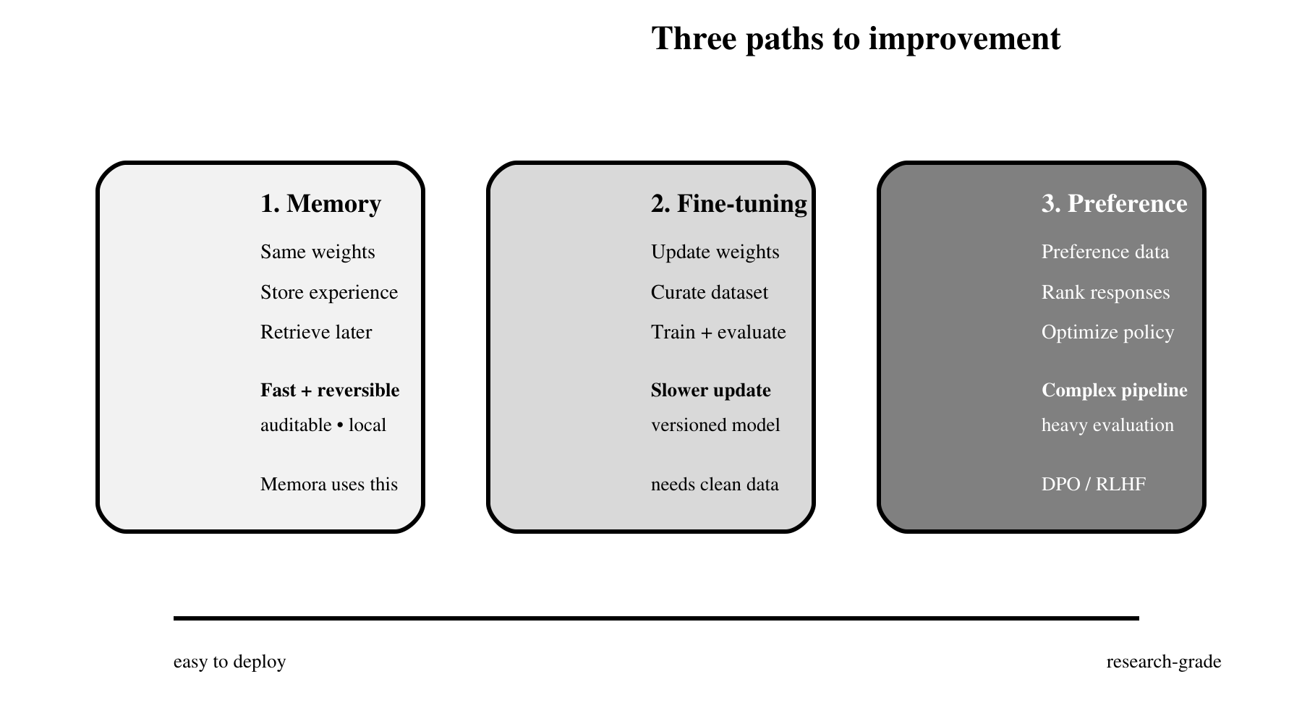
Figure 28.1 — Memory, fine-tuning, and preference optimization change different parts of the system.
Figure 28.1 orders the mechanisms by operational weight, not by prestige. Moving right changes a broader and less immediately reversible artifact, so the evidence and evaluation burden rises with it.

28.3.1 Memory injection
Memory injection stores selected experience outside the model and retrieves it when relevant. The stored unit might be a corrected answer, a distilled Q&A pair, a failed query variant, a user preference, or a procedural note. It is fast to update, easy to inspect, and reversible: remove or supersede a record and future context changes immediately.
Memora implements multiple memory roles. The `documents` collection is source knowledge. The `learned_qa` collection is episodic experience distilled into reusable semantic form. Thumbdowns and failed variants are failure memory used to steer repeated searches. These tracks remain separate so provenance and precedence do not disappear into one undifferentiated vector pool.

28.3.2 Fine-tuning on accumulated interactions
Fine-tuning converts curated examples into parameter updates. It is appropriate when the desired behavior is broad and repeated—such as a stable response format, domain vocabulary, or decision style—and enough high-quality examples exist. It requires a dataset pipeline, train/validation split, compute, model versioning, regression evaluation, and rollback. New facts are usually a poor target because retrieval can update them more cheaply and transparently.

28.3.3 RLHF and DPO
Preference optimization learns from comparisons or reward signals rather than only target completions. RLHF trains or uses a reward model and optimizes a policy against that signal. DPO uses preferred and rejected response pairs through a simpler direct objective. Both demand careful preference data and strong evaluation because optimizing a proxy can create fluent but undesirable shortcuts.
Path | Artifact changed | Update speed | Rollback / audit
Memory injection | External records and retrieval context | Immediate | Delete, edit, or version records
Fine-tuning | Model checkpoint / adapters | Batch process | Deploy prior checkpoint; compare runs
RLHF / DPO | Policy parameters | Research pipeline | Checkpoint rollback; complex causal audit

28.3.4 Choosing the smallest sufficient mechanism
Choose by asking what must change. If a new policy fact or corrected answer should take effect tomorrow, update a governed memory record. If thousands of examples reveal a stable formatting or reasoning behavior that prompts cannot reliably produce, evaluate fine-tuning. If the goal is a nuanced preference that is easier to rank than to write as a target answer, preference optimization may be justified. Do not choose a heavier mechanism merely because it sounds more advanced.
Observed need | First mechanism to test | Evidence before escalation
Current or user-specific knowledge | Memory plus retrieval | Retrieval benchmark and conflict policy
Repeated output-format failures | Prompt/schema, then fine-tuning | Large clean example set and regression suite
Subjective response preference | Prompt/rubric, then DPO or RLHF | Consistent human preference pairs
One bad answer | Correct or quarantine one record | Do not retrain from an anecdote

A useful escalation rule is reversibility first. Begin with the change that can be inspected, evaluated, and rolled back at the finest granularity. Memory can be removed record by record; a prompt can be versioned; a checkpoint changes behavior globally. The broader the artifact, the stronger the dataset and evaluation burden must be.

28.4 Why memory injection is the right choice for most projects
Most application teams need current facts, user-specific corrections, and operational lessons—not a continuously retrained foundation model. Memory injection fits that need because it separates the stable model from the changing experience layer. It can work with hosted APIs, update after one verified event, preserve provenance, and support deletion obligations.
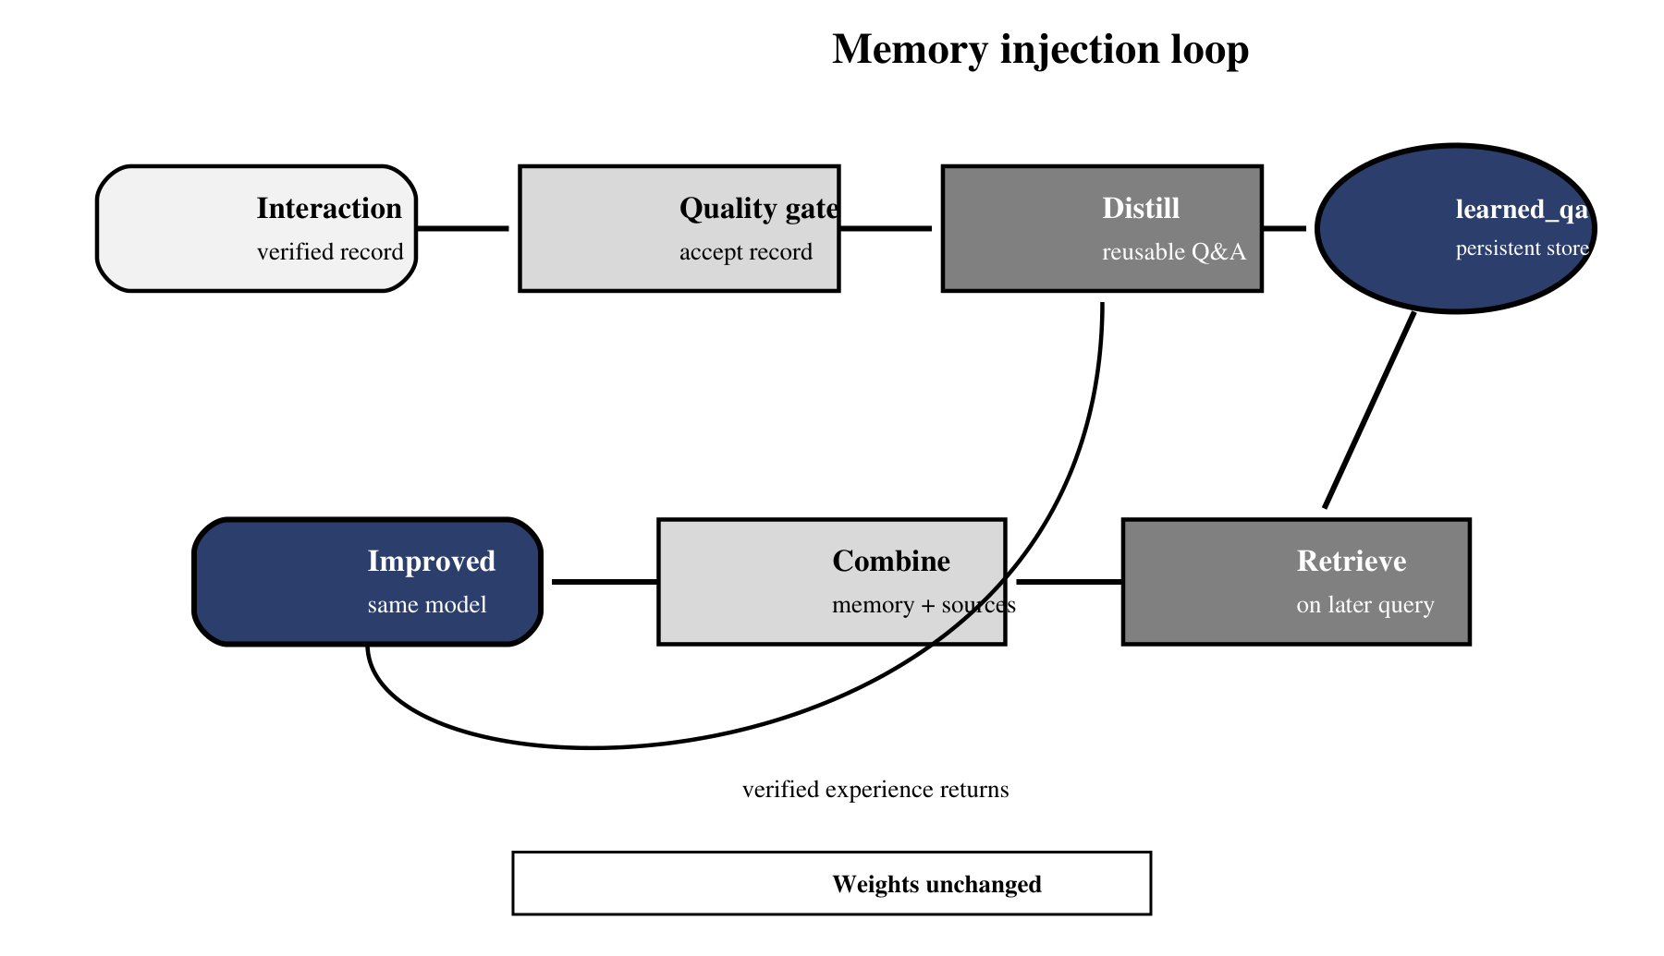
Figure 28.2 — Memora improves later context while leaving the base model unchanged.
In Figure 28.2, the quality gate and distillation step are the critical brake. Without them, the loop would merely recycle model output; with them, it can convert verified experience into a bounded external record.
A production memory loop should be selective. Record the interaction and its evidence; apply a quality gate; distill only reusable information; attach provenance and timestamps; deduplicate before writing; retrieve memory on a later question; and combine it with source documents under an explicit conflict rule. Memora prefers learned Q&A when its curated memory conflicts with raw documents, while preserving both tracks for audit.
def maybe_learn(interaction, memory_store):
if not interaction.quality_verified:
return "rejected"
if not interaction.has_grounded_evidence:
return "rejected"

candidate = distill(interaction)
candidate.provenance = interaction.source_ids
candidate.created_at = utc_now()

if memory_store.is_duplicate(candidate):
return "duplicate"
memory_store.upsert(candidate)
return "stored"

- Immediate updates without a training job or model redeployment.
- Record-level provenance, review, deletion, and expiry.
- Different memory types can use different retrieval thresholds and precedence.
- A bad write can be corrected without rolling back an entire model checkpoint.
- The same memory layer can support several interchangeable base models.

28.4.1 Designing a memory record
The reusable unit should contain more than question and answer text. Store a stable record ID, normalized query, distilled answer, source identifiers, memory type, owner or tenant scope, creation time, quality status, model or pipeline version, expiry, and supersession link. Keep the original interaction in a separate restricted ledger when policy permits; retrieval should receive the compact record, not an accidental dump of private conversation history.
memory = {
"id": stable_hash(tenant, normalized_query, answer),
"query": normalized_query,
"answer": distilled_answer,
"source_ids": verified_source_ids,
"kind": "learned_qa",
"tenant": tenant_id,
"quality": "verified",
"created_at": utc_now(),
"expires_at": policy_expiry(),
"supersedes": prior_record_id,
}

Consider a worked lifecycle. A user asks how Memora handles two meanings of `ASD`. The first run retrieves both domains and produces a grounded clarification. A quality gate verifies the citations, and the distiller stores a concise Q&A explaining that ambiguity should trigger a clarifying question rather than premature commitment. Weeks later, a similar request retrieves that memory alongside current documents. If the source corpus has changed, the documents still supply the facts while memory supplies the successful strategy.
Now imagine the user later corrects the preferred terminology. The system should create a reviewed successor record, mark the old record superseded, and exclude it from ordinary retrieval while retaining provenance for audit. This is safer than overwriting history invisibly and far safer than allowing two contradictory records to compete by embedding similarity alone.

28.4.2 Conflict and precedence rules
Memory becomes dangerous when similarity silently decides authority. Define precedence by record type and freshness. A current approved policy document should outrank an old learned answer about policy. A verified user preference may outrank a generic style memory for that user but must not alter another tenant. When evidence conflicts, surface the disagreement or request clarification instead of averaging incompatible claims into fluent prose.
Conflict | Preferred action | Reason
Current source vs. stale learned fact | Use source; expire or review memory | Facts belong to maintained sources
Verified correction vs. prior memory | Retrieve successor only | Supersession is explicit
Tenant preference vs. global style | Apply only within tenant scope | Prevents cross-user leakage
Two current authoritative sources | Expose conflict or escalate | Similarity cannot resolve authority

Log which rule resolved the conflict and which record IDs were suppressed. That metadata makes later evaluation possible: if an answer regresses, investigators can tell whether retrieval missed the right memory, precedence selected the wrong one, or generation misused correct context.
Keep a no-memory baseline for comparison. If the governed memory path cannot outperform that baseline on repeated questions without increasing unsupported claims, the system has accumulated records but has not demonstrated learning. Improvement is an empirical result, not a storage-count metric.

28.5 Dangers of unchecked self-learning
A system that writes its own outputs back into memory creates a feedback loop. If an unsupported answer is stored, later retrieval may present it as prior knowledge; the model then repeats it with greater confidence, generating more interactions that reinforce the same error. This is memory pollution: the store accumulates records whose authority exceeds their evidence.
Risk | Failure pattern | Control
Hallucination reinforcement | Model output becomes future evidence | Require grounded sources and an independent quality gate
Stale memory | Old policy or preference outranks current truth | Timestamp, expire, supersede, and revalidate
User poisoning | Malicious feedback inserts false guidance | Authenticate, rate-limit, quarantine, and review
Privacy leakage | Sensitive interaction becomes broadly retrievable | Minimize data, scope by user/tenant, support deletion
Duplicate amplification | Near-identical records dominate retrieval | Stable IDs, semantic deduplication, and caps
Evaluation blindness | More memory is assumed to mean better answers | Maintain a fixed benchmark and compare over time

Common pitfall — Using the model as both author and sole judge
If one model generates an answer, declares it correct, distills it, and stores it without external evidence, the loop has no independent brake. Require source grounding, deterministic checks where possible, user review for high-impact writes, and delayed evaluation on a fixed test set.

28.5.1 Evaluation, rollback, and forgetting
Evaluate memory on two axes. Retrieval quality asks whether the right record appears without crowding out source documents. Answer quality asks whether adding that record improves grounded correctness on a fixed benchmark. Track both because a memory can be retrieved accurately yet still contain stale or misleading guidance. Compare runs with memory enabled and disabled, and preserve the retrieved record IDs so improvements and regressions can be attributed.
Every write path needs a reverse path. Quarantine suspicious records immediately, supersede corrected records explicitly, expire time-sensitive records, and delete records when privacy or policy requires it. After deletion, test representative queries against every collection and cache. A system that can add experience but cannot locate and remove it is accumulating liability, not learning responsibly.
The honest goal is not to remember everything. Production memory research emphasizes distilled experience: retain what is likely to help a future task, discard noise, and make forgetting a first-class operation. A useful memory store is curated, scoped, versioned, and evaluated—not merely large.
Chapter 29 turns these principles into the feedback ledger. We will define which interaction fields to log, distinguish implicit from explicit feedback, design a lightweight JSONL record, and decide what privacy-sensitive information must never be stored.

